

IBM CAREER EDUCATION

**MAIN PROJECT**

**DOMAIN NAME: JAVA**

**HOTEL MANAGEMENT SYSTEM**

**Submitted By,**

|  |  |  |
| --- | --- | --- |
| Name | Course | Enrollment No. |
| Simran Patel | B-tech (CBA) | 18162101023 |
| Yashvi Gandhi | DD BCACBA-08 | 18082271008 |

II Year – (CBA) ‘A’ Section

Ganpat University, Ahmedabad.

**Submitted To,**

Saai Sanjeev Achaarya

IBM Software Technical Trainer



2

HOTEL MANAGEMENT SYSTEM

**FLOWCHART**

Start

End

Choice given through if-else statement

Billing

Cancellation

Check out

Check In

Booking

Define the variables and thereby include all the modules of the project

Declared the variables used

3

HOTEL MANAGEMENT SYSTEM

SOFTWARE SPECIFICATIONS

* OPERATING SYSTEM : Windows
* ENVIRONMENT : VMware Workstation

HARDWARE SPECIFICATIONS

* + PROCESSOR : Core™i3-7020U CPU @2.30 GHz
  + RAM : 8.00 GB (7.89 GB usable)
  + MONITOR : 15” COLOR
  + HARD DISK : 40 GB
  + FLOPPY DRIVE : 1.44 MB

4

HOTEL MANAGEMENT SYSTEM

DESCRIPTION

INTRODUCTION: The project, Hotel Management System is a web-based application that allows

Interactive GUI and the ability to manage various hotel bookings and rooms make this system very flexible and convenient.

The hotel manager is a very busy person and does not have the time to sit and manage the entire activities manually on paper. This application gives him the power and flexibility to manage the entire system from a single online system.

Hotel management project provides room booking, staff management and other necessary hotel management features. The system allows the manager to post available rooms in the system.

Customers can view and book room online. Admin has the power of either approving or disapproving the customer’s booking request. Other hotel services can also be viewed by the customers and can book them too.

The system is hence useful for both customers and managers to portable manage the hotel activities.

PROS:

* Sometime it happens that the rooms get booked soon when one visits the place therefore user can make advance booking using this system.
* It saves user time in searching a room.
* The system is useful as it calculates an exact cost of rooms for requested number of days.
* It saves organization resources and expenses.
* This system is effective and saves time and cost of users.

CONS:

* The booking process usually requires a customer identity, which the system cannot detect.
* It requires a reliable internet connection.
* Updating data would be difficult in case of change in details

6

HOTEL MANAGEMENT SYSTEM

PICTURES

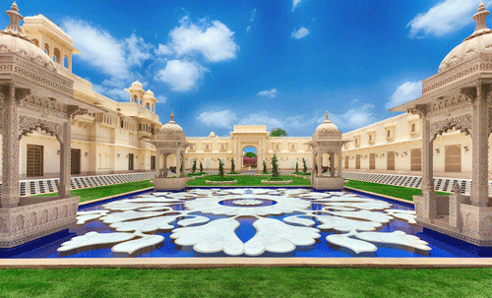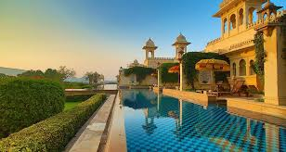

7

HOTEL MANAGEMENT SYSTEM

AIM:

* Home-page, Booking and cancellation.
* Check in Details, Check out details.
* Compute the bills, Feedback.

PROGRAM:

Home page code:-

<html>

<head>

<title>Hotel management</title>

<link rel="icon" type="image/png" href="head.png">

<style>

@media only screen and (min-width: 600px)

{

.dd1

{

background-color:black;

background-image:url('head.png');

background-size: 200px 130px;

background-repeat: no-repeat;

opacity: 1;

}

.hed

{

text-align: center;

text-shadow: 2px 2px black;

text-decoration: underline;

}

.sub

{

text-align: center;

text-shadow: 1px 1px black;

}

font

{

font-family:Castellar;

color:white;

}

body

{

background-image: url("pic1.jpg");

}

{

margin:0;

font-family: Times New Roman;

}

.navi

{

overflow: hidden;

background-color:black;

}

.navi a

{

float: right;

color:white;

text-align: center;

padding: 14px 17px;

text-decoration: none;

font-size: 17px;

}

/* .navi a:hover

{

background-color:tomato;

color:black;

} */

.navi a.active

{

background-color:#46C8A6;

color:black;

}

img {

border-color:black;border-style:solid;border-width:5;

}

img:hover {

width:400px;

border-radius:25px;

}

.bb:hover {

background:#46C8A6;

letter-spacing:5px;

color:#191970;

}

.dd2

{

background-color:#46C8A6;

position: relative;

-webkit-animation-name: example;

-webkit-animation-duration: 4s;

animation-name: example;

animation-duration: 4s;

}

@-webkit-keyframes example {

0% {background-color:black; left:0px; top:0px;}

25% {background-color:white; left:200px; top:0px;}

50% {background-color:black; left:200px; top:200px;}

75% {background-color:white; left:0px; top:200px;}

100% {background-color:black; left:0px; top:0px;}

}

@keyframes example {

0% {background-color:black; left:0px; top:0px;}

25% {background-color:white; left:200px; top:0px;}

50% {background-color:black; left:200px; top:200px;}

75% {background-color:white; left:0px; top:200px;}

100% {background-color:black; left:0px; top:0px;}

}

.btn {

background-color:grey;

border: none;

color: black;

padding: 16px 16px;

text-align: center;

font-size: 16px;

margin: 2px 2px;

transition: 0.3s;

}

.btn:hover {

background-color:#1E90FF;

color: white;

}

</style>

</head>

<body>

<div>

<div style="width:100%; height:15%" class="dd1">

<font color="white">

<h1 class="hed">THE OBEROI GROUP</h1>

<h4 class="sub">EXPERIENCE BEST LIVING</h4>

</font>

</div>

</div>

<div style="width:75%; height:6%;" class="navi">

<a href="bok.html" target="_blank">Check Out</a>

<a href="fare.html" target="_blank">Check In</a>

<a href="contact.html" target="_blank">Cancellation</a>

<a href="about.html" target="_blank">Booking</a>

<a class="active">Home</a>

</div>

<div style="float:right; height:85%; width:20%;" class="dd2">

<a href="p1.html" target="_self">

<h1 class="btn">MUMBAI, INDIA</h1>

</a>

<a href="p2.html" target="_self">

<h1 class="btn">MELBOURNE, AUSTRALIA</h1>

</a>

<a href="p3.html" target="_self">

<h1 class="btn">CALIFORNIA, US</h1>

</a>

<a href="p5.html" target="_self">

<h1 class="btn">PARIS, FRANCE</h1>

</a>

<a href="p6.html" target="_self">

<h1 class="btn"> LONDON, ENGLAND</h1>

</a>

<a href="p7.html" target="_self">

<h1 class="btn">ONTARIO, CANADA</h1>

</a>

<a href="p8.html" target="_self">

<h1 class="btn">LAS VEGAS, US</h1>

</a>

<a href="p9.html" target="_self">

<h1 class="btn">PENANG, MALASIA</h1>

</a>

<a href="p10.html" target="_self">

<h1 class="btn">CAPE TOWN, SOUTH AFRICA</h1>

</a>

</div>

<div style="width:75%; height:79%; margin:15px;">

<center><h1 class="bb">WELCOME TO THE WORLD OF BEST HOSPITALITY</h1></center><hr>

</div>

</div>

</body>

</html>

Java code:-

import java.util.*;

class Hotel_management

{

public static void main(String s[])

{

int i,days,booking_number,room_number,room_cost,food_cost,service_cost;

String name,feedback,time;

long arrival,departure,contact_number;

Scanner sc = new Scanner (System.in);

System.out.println("*****************************************");

System.out.println(" OBEROI HOTELS ");

System.out.println("*****************************************");

System.out.println("| 1. Booking |");

System.out.println("| 2. Cancellation |");

System.out.println("| 3. Check In |");

System.out.println("| 4. Check Out |");

System.out.println("*****************************************");

System.out.print("Enter your choice : ");

i = sc.nextInt();

if (i == 3)

{

System.out.println("\n #### Check In #### \n ");

System.out.println("Enter Booking number: ");

booking_number = sc.nextInt();

System.out.println("Enter customer's name: ");

name = sc.next();

System.out.println("Enter customer's contact number: ");

contact_number = sc.nextInt();

System.out.println("Enter room number: ");

room_number = sc.nextInt();

System.out.println("Enter time of Check in: ");

time=sc.next();

System.out.println("___________________________________________");

}

else if (i == 1)

{

System.out.println("\n #### Booking #### \n ");

System.out.println("Enter customer's name: ");

name = sc.next();

System.out.println("Enter customer's contact number: ");

contact_number = sc.nextLong();

System.out.println("Enter the date of arrival (dd.mm.yyyy): ");

arrival= sc.nextLong();

System.out.println("Enter the booking number given: ");

booking_number= sc.nextInt();

System.out.println("Enter the date of departure(dd.mm.yyyy): ");

departure= sc.nextLong();

System.out.println("YOUR BOOKING IS CONFIRMED ");

System.out.println("___________________________________________");

}

else if (i == 2)

{

System.out.println("\n #### Cancellation #### \n ");

System.out.println("Enter customer's name: ");

name= sc.next();

System.out.println("Enter customer's contact number: ");

contact_number = sc.nextLong();

System.out.println("Enter the booking number given: ");

booking_number= sc.nextInt();

System.out.println("Enter the number of days from booking till now: ");

days= sc.nextInt();

if (days<2)

{

System.out.println("60 percent payment is returned.");

}

else if (days>2 && days<10)

{

System.out.println("40 percent payment is returned. ");

}

else if (days>10 && days<15)

{

System.out.println(" 20 percent payment is returned. ");

}

else

{

System.out.println("No refund.");

}

System.out.println("___________________________________________");

}

else if (i == 4)

{

System.out.println("\n #### Check Out #### \n ");

System.out.println("Enter Booking number: ");

booking_number= sc.nextInt();

System.out.println("Enter customer's name: ");

name= sc.next();

System.out.println("Enter customer's contact number: ");

contact_number = sc.nextLong();

System.out.println("Enter cost of room: ");

room_cost= sc.nextInt();

System.out.println("Enter cost of food: ");

food_cost = sc.nextInt();

System.out.println("Enter cost of services: ");

service_cost= sc.nextInt();

System.out.println("*****************************************");

System.out.println(" BILL ");

System.out.println("*****************************************");

System.out.println("| 1.Cost of room |" +room_cost);

System.out.println("| 2. Cost of food |" +food_cost);

System.out.println("| 3. Cost of service |" +service_cost);

System.out.println("| TOTAL |" +(room_cost+food_cost+service_cost));

System.out.println("*****************************************");

System.out.print(" #### FEEDBACK: ");

feedback = sc.next();

System.out.println("*****************************************");

System.out.println("THANK YOU FOR YOUR VISIT !");

System.out.println("________ We hope to meet you again.____________");

System.out.println("___________________________________________");

}

else

{

System.out.println(" WRONG INPUT !!");

}

}

}

Webpage code of Check-in,Check-out page:-

<html>

<head>

<title>check in form</title>

<link rel="icon" type="image/png" href="head.png">

<link rel="stylesheet" type="text/css" href="bok.css"/>

</head>

<body>

<script>

function myfunction()

{

alert("your room is booked.")

}

</script>

<div id="b" class="s11">

<div class="sc">

<div class="main">

<div class="r">

<div class="bk">

<form method="post">

<div class="r">

<div class="c6">

<div class="fg">

<span class="fl">Name</span>

<input class="fc" type="text" required>

</div>

</div>

<div class="c6">

<div class="fg">

<span class="fl">Branch </span>

<input class="fc" type="text" required>

</div>

</div>

</div>

<div class="r">

<div class="c3">

<div class="fg">

<span class="fl"> Checked in </span>

<input class="fc" type="date" required>

</div>

</div>

<div class="c3">

<div class="fg">

<span class="fl">Checked out</span>

<input class="fc" type="date" required>

</div>

</div>

<div class="c3">

<div class="fg">

<span class="fl">Date of Check in</span>

<input class="fc" type="date" required>

</div>

</div>

<div class="c2">

<div class="fg">

<span class="fl">Adults (18+)</span>

<select class="fc">

<option>0</option>

<option>1</option>

<option>2</option>

<option>3</option>

</select>

<span class="sa"></span>

</div>

</div>

<div class="c2">

<div class="fg">

<span class="fl">Children (0-17)</span>

<select class="fc">

<option>0</option>

<option>1</option>

<option>2</option>

<option>3</option>

</select>

<span class="sa"></span>

</div>

</div>

</div>

<div class="r">

<div class="c3">

<div class="fg">

<span class="fl">Type of room</span>

<select class="fc">

<option>Select</option>

<option>single room</option>

<option>Double room</option>

<option>Dulex room</option>

</select>

<span class="sa"></span>

</div>

</div>

<div class="c3">

<div class="fb">

<button class="sb" onclick="myfunction()">Confirm</button>

</div>

</div>

</div>

</form>

</div>

</div>

</div>

</div>

</div>

</body>

</html>

8

EXPLANATION ABOUT PROJECT:

A Hotel management system is a computerized management system. This system keeps the records of hardware assets besides software of this organization. The proposed system will keep a track of Workers, Residents, Accounts and generation of report regarding the present status. This project has GUI based software that will help in storing, updating and retrieving the information through various user-friendly menu-driven modules. The project “Hotel Management System” is aimed to develop to maintain the day-to-day state of admission/Vacation of residents, List of Workers, payment details etc. Main objective of this project is to provide solution for hotel to manage most their work using computerized process.

This software application will help admin to handle customers information, room allocation details, payment details, billing information. Detailed explanation about modules and design are provided in project documentation. The existing system is a manually maintained system. All the Hotel records are to be maintained for the details of each customers, Fee details, Room Allocation, Attendance etc. All these details are entered and retrieved manually, because of this there are many disadvantages in ancient paper method like Time Consuming, difficulty updating process and data, inaccuracy of data. For avoiding this we introduced or proposed a new system in proposed system the computerized version of the existing system. provides easy and quick access over the data.

In hotel operations, procurement of goods and services is the most vulnerable area which could lead to malpractice because hotels spend substantial amounts on goods (such as food and beverage, utensils, toiletries etc.) and services (such as cleaning and security services, group insurance services etc.). Besides making sure that purchases are value for money, it is important for the hotel management to establish a fair and competitive procurement system with sufficient safeguards to prevent abuse by unscrupulous staff. As hotel maintenance and renovation also incur considerable expenses and there is much room for corrupt manipulation in the letting and supervision of works contractors

If these codes are connected through JDBC and some functions of Java Advance are used, then all the data entered should be stored in a database (maybe created through XAMPP through Mysql) and fetching of the data, updating, deletion etc. functions should reciprocate in the table stored.

9

OUTPUT SCREENSHOTS:

**Screenshot of hotel booking website**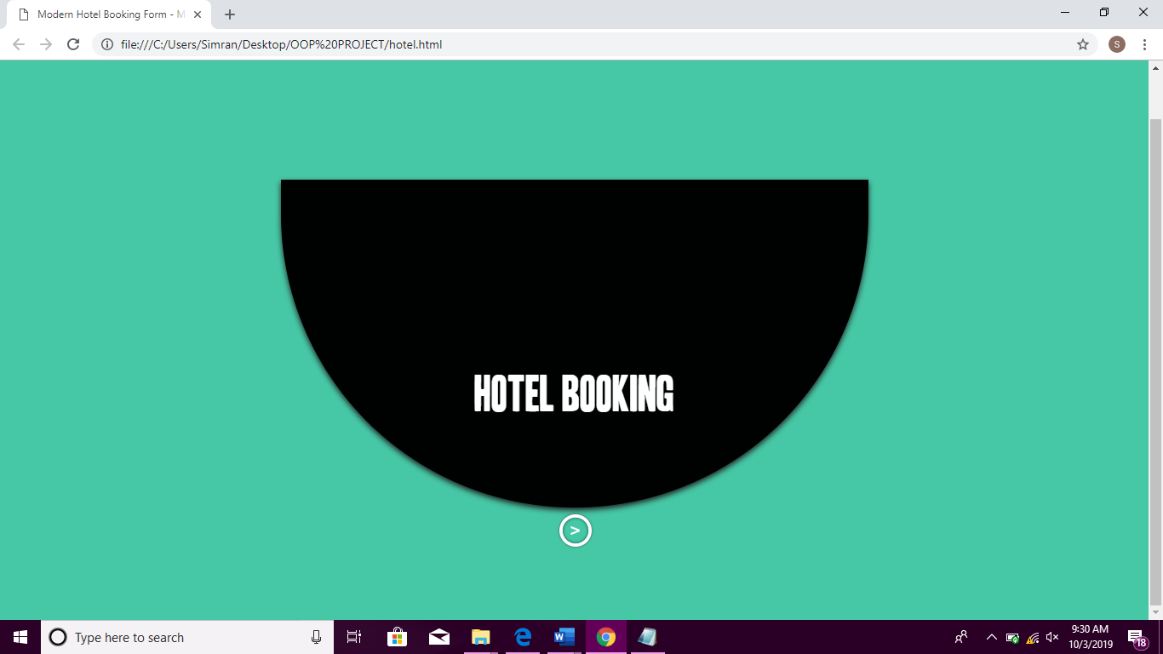:- 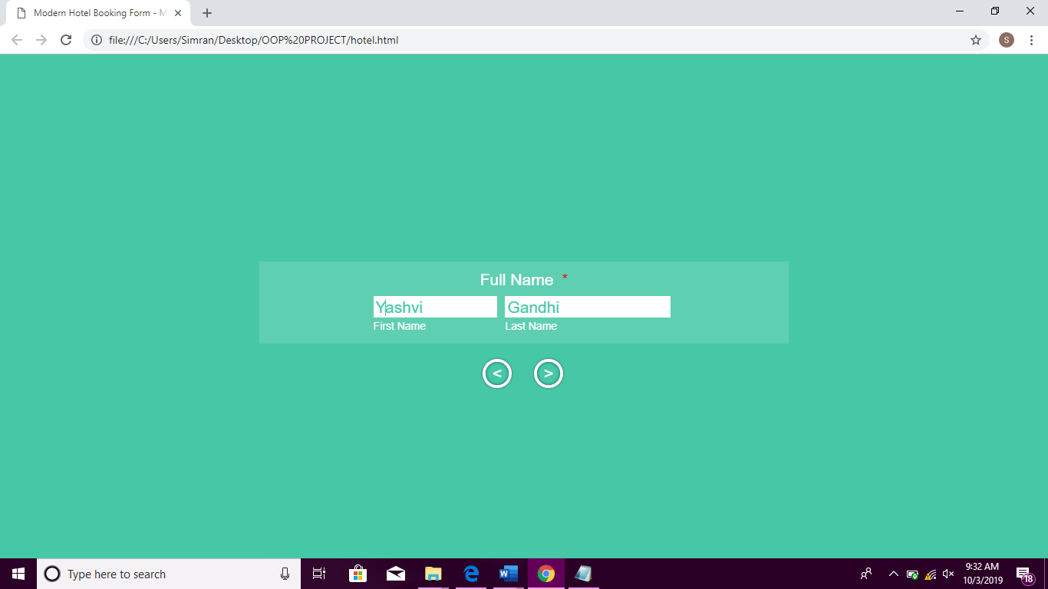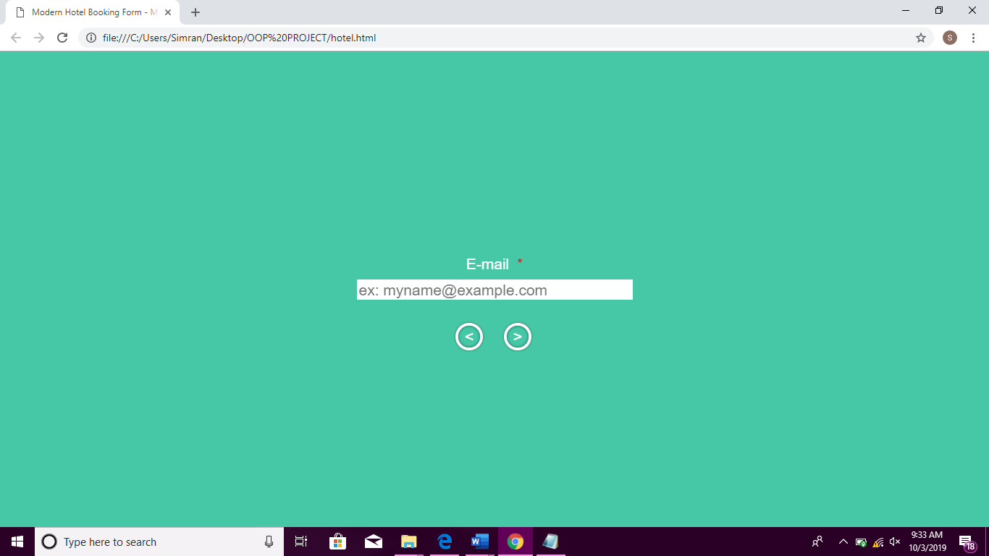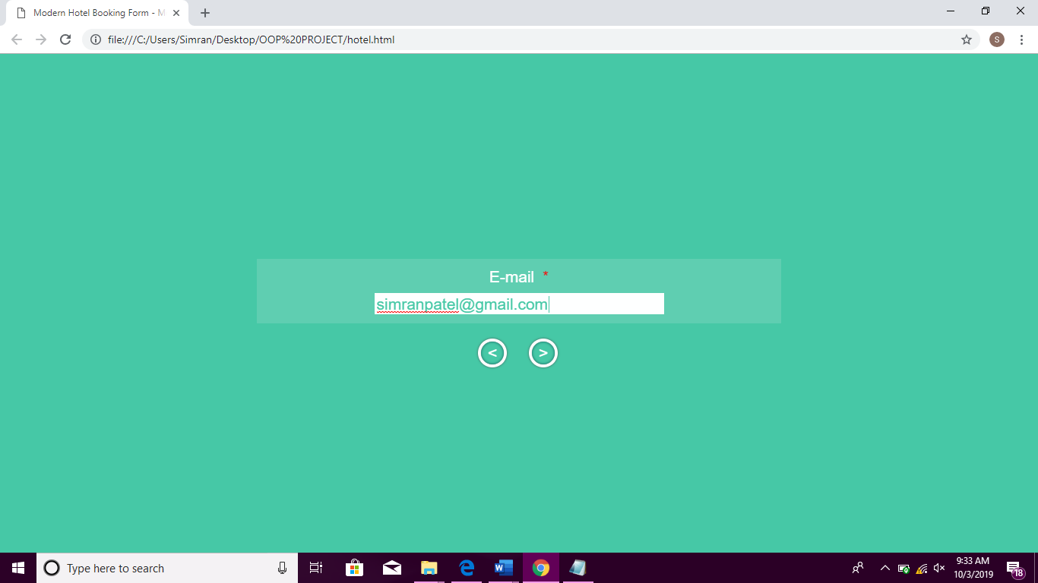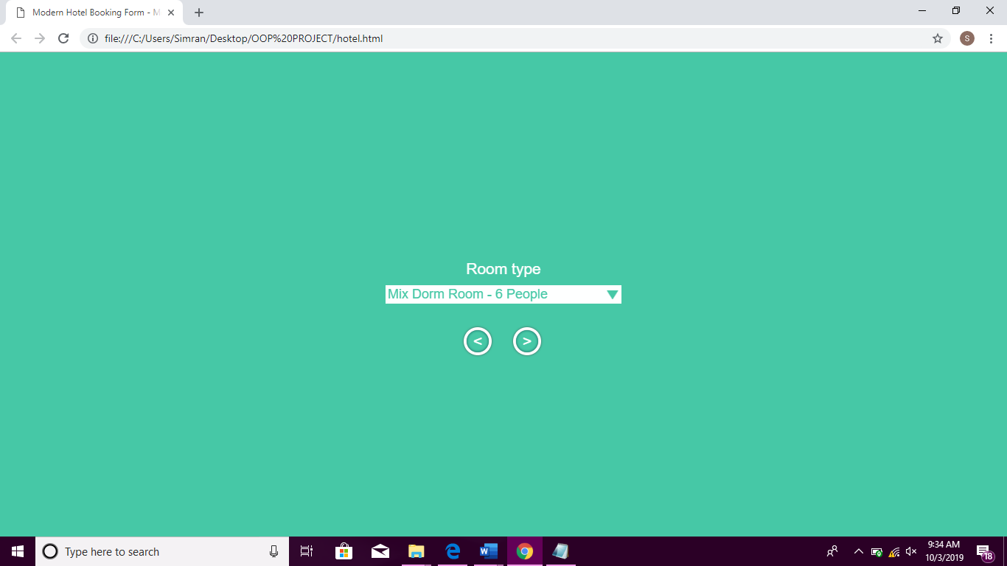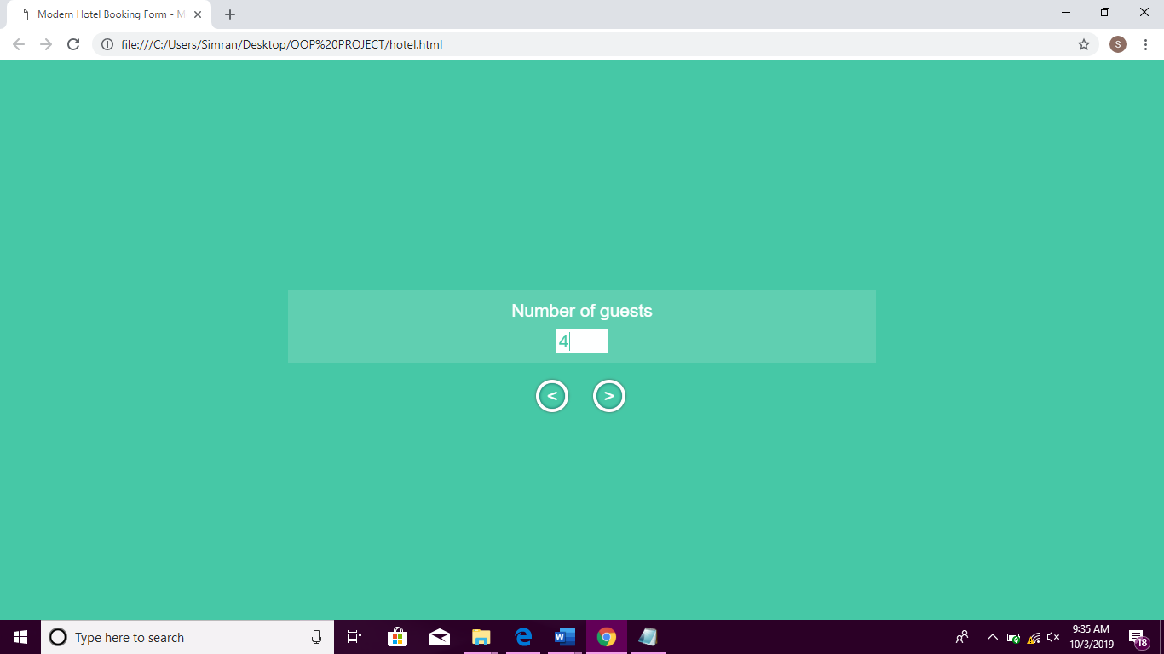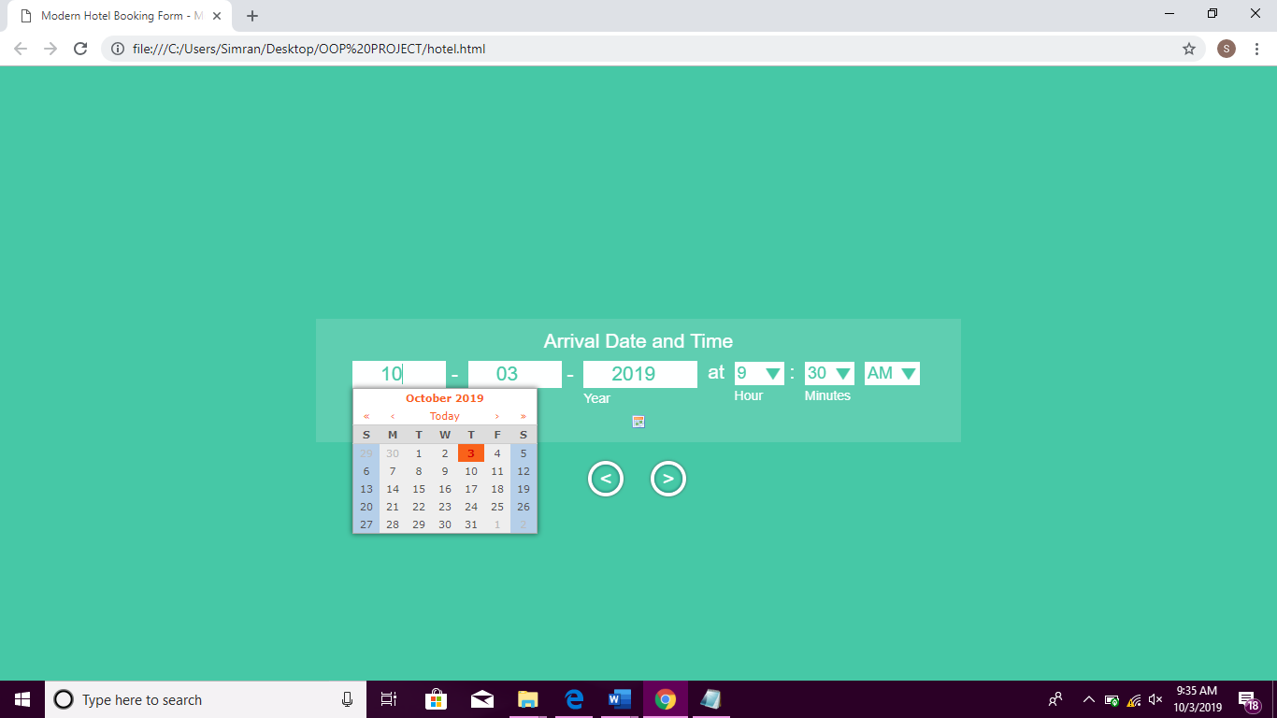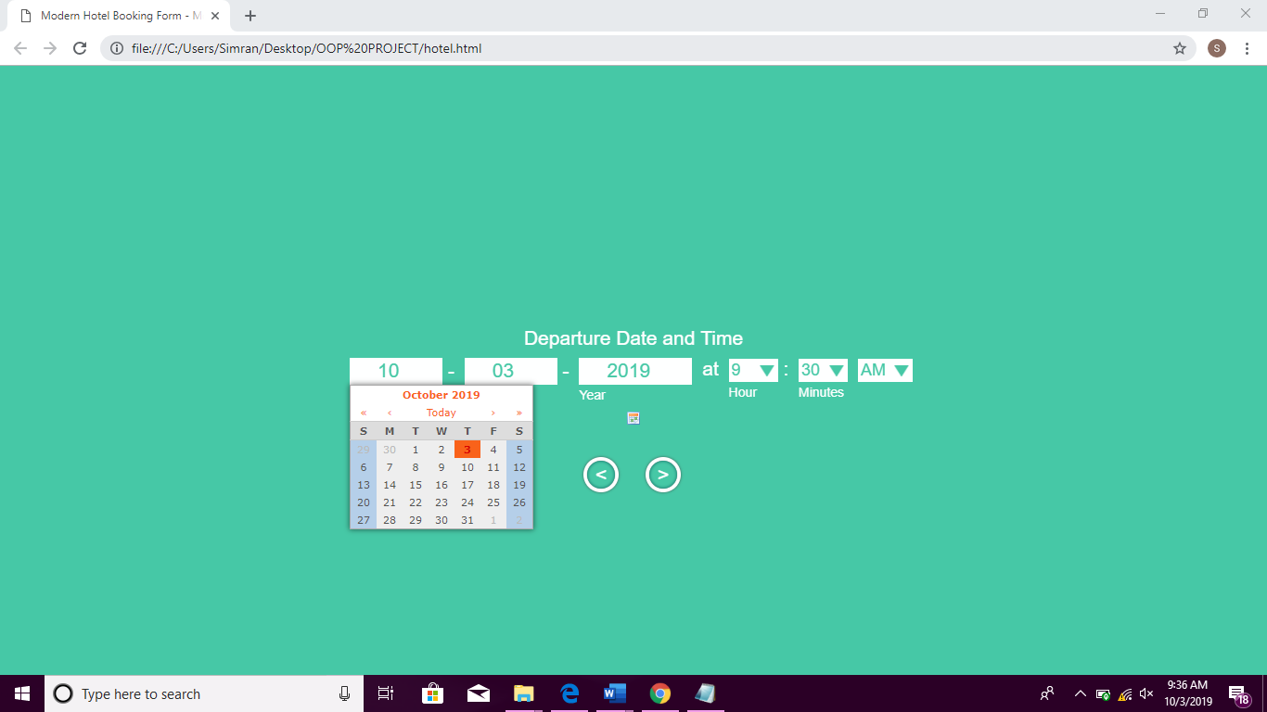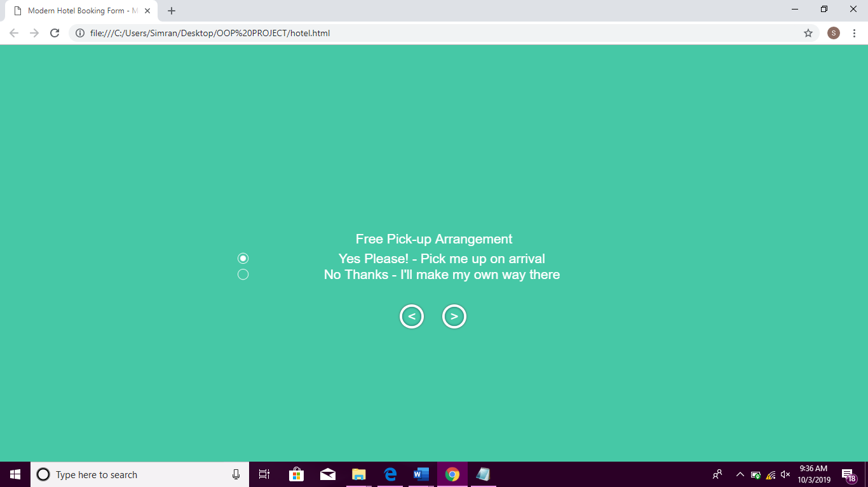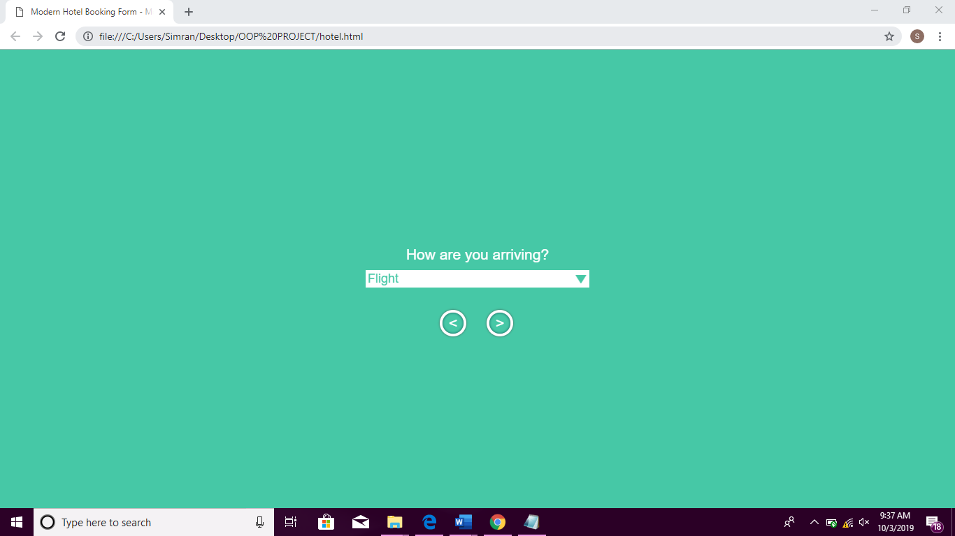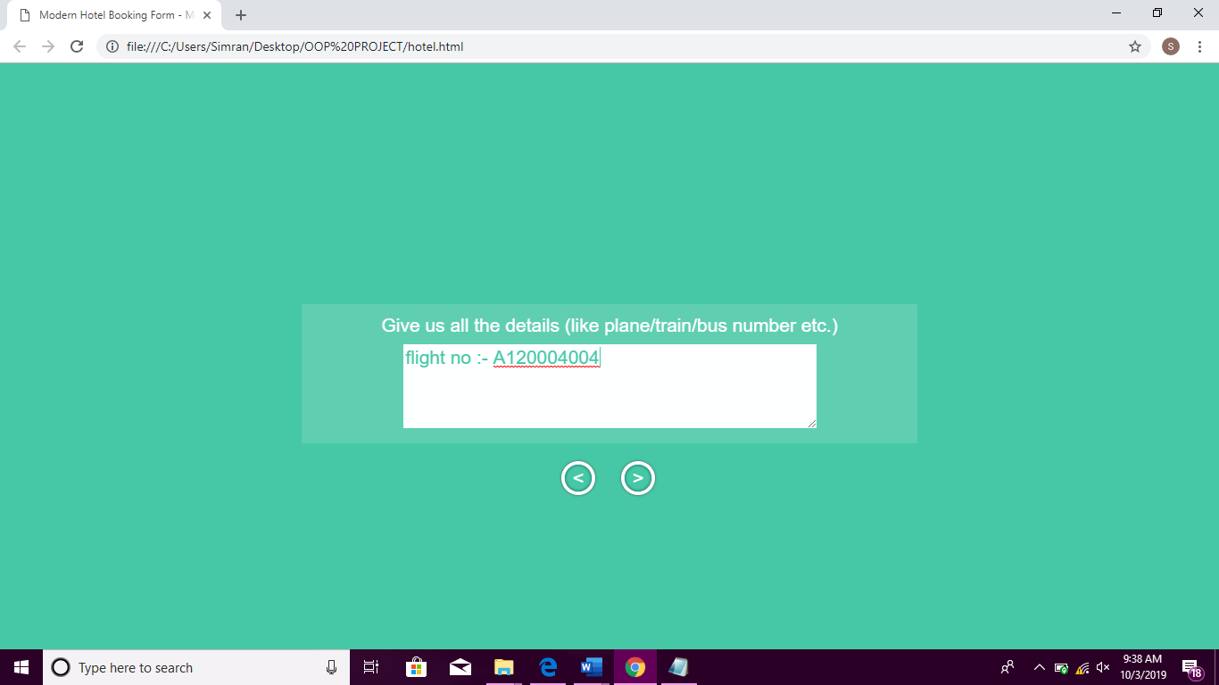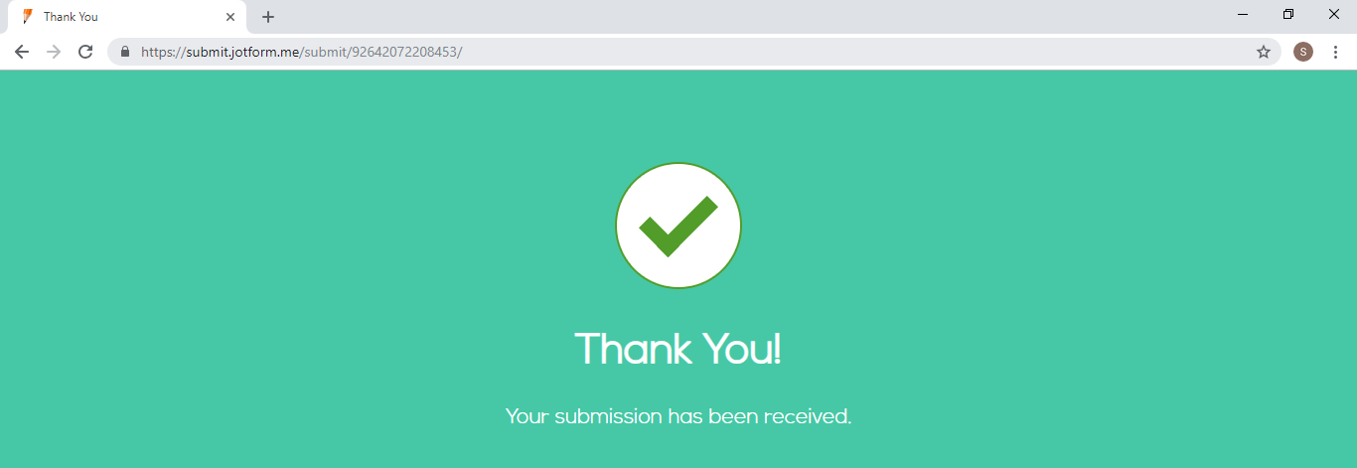

**Screenshot of check in – check out website: -**

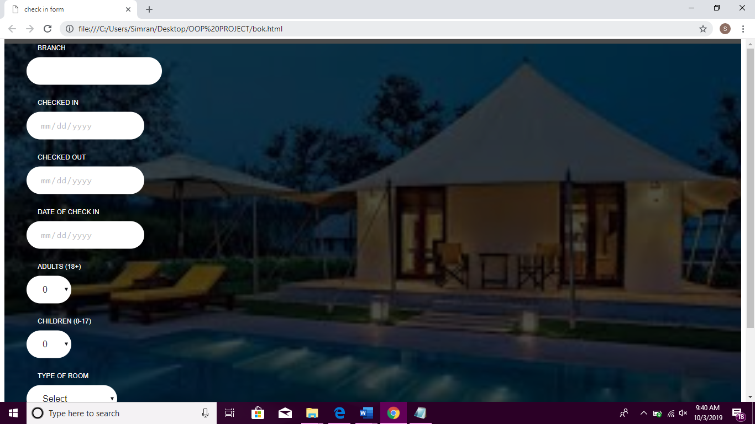

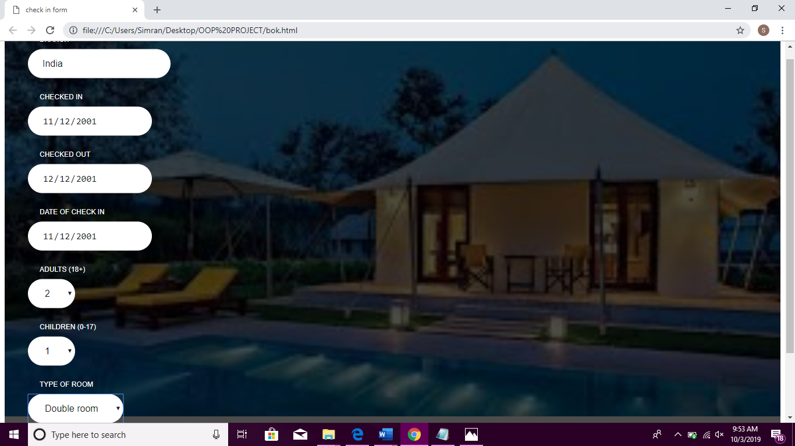

**Screenshots of Home page :-**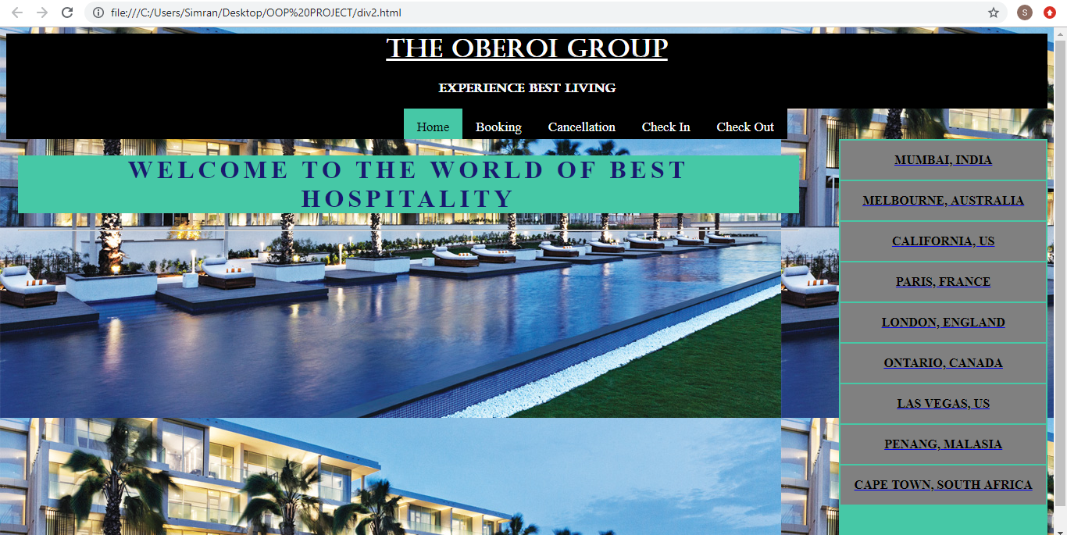

**Screenshots of output of java :-**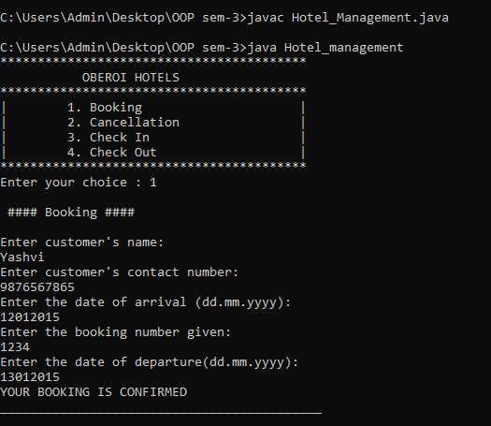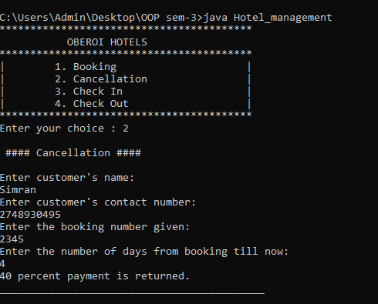

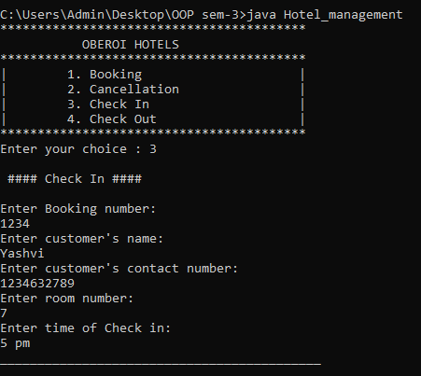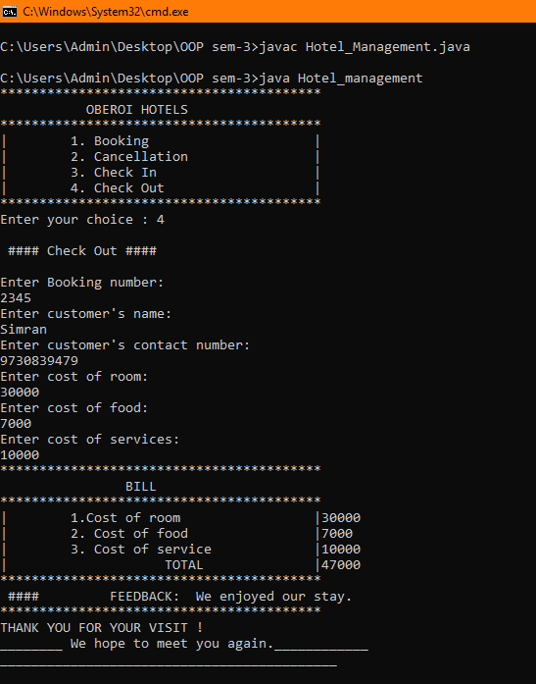

REFERENCES:

* <https://www.jotform.com>
* <https://www.google.com/search?q=images+for+oberoi+hotel&sxsrf=ACYBGNS7zxj4K1zQMHTVXwlQBuIfsJEfnw:1570129427303&source=lnms&tbm=isch&sa=X&ved=0ahUKEwiU6I_244DlAhVOfSsKHViJAeAQ_AUIEigB&biw=1366&bih=657>
* <https://sites.google.com/site/onlinehotelmanage/project-description-1>

CONCLUSION:

Thus, this project leads to understandable way of keeping the records, ease and methodical access of records security of consumer’s details.